Title: Do low oxygen environments facilitate invasion? Relative tolerance of native and invasive species to low oxygen conditions

Running head: Marine invasive species in hypoxic habitats

Authors: Marcelo E. Lagos 1, Diego R. Barneche 1, Craig R. White 1,2, Dustin J. Marshall 1.

Institute or laboratory of origin:

1School of Biological Sciences/Centre for Geometric Biology, Monash University,

Clayton, VIC 3800, Australia.

2

Corresponding author’s telephone, and email details:

Marcelo E. Lagos , +61 3 99054614, lagosorostica@gmail.com.

Diego R. Barneche, +61 3 99055100, [barnechedr@gmail.com](mailto:diego.barneche@monash.edu)

Craig R. White , [+61 3 99020769](tel:%2B61%203%209902%200769), craig.white@monash.edu

Dustin J. Marshall , +61 3 99024449, [dustin.marshall@monash.edu](mailto:dustin.marshall@monash.edu&subject=Enquiry%20submitted%20via%20MEEG%20website)

Keywords: Non-indigenous species, sessile organisms, low flow, low oxygen, exploitative competition, invasions, artificial structures, marinas.

Paper type: Primary Research

**Abstract**

Biological invasions are one of the biggest threats to global biodiversity. Marine artificial structures are proliferating worldwide and provide a haven for marine invasive species. Such structures disrupt local hydrodynamics, which can lead to the formation of oxygen-depleted microsites when the rate of oxygen consumption by fouling communities exceeds the rate of oxygen replenishment. The extent to which native fauna can cope with such low oxygen conditions, and whether invasive species, long associated with artificial structures in flow-restricted habitats, have adapted to these conditions remains unclear. We measured water flow oxygen availability in marinas and piers at the scales relevant to sessile marine invertebrates (mm). We then measured the capacity of invasive and native marine invertebrates to maintain metabolic rates under decreasing levels of oxygen using standard la1boratory assays. We found that marinas reduce the water flow relative to piers, and that local oxygen levels can be as low as zero in these low flow conditions. We also found that for species with arborescent growth forms, invasive species can tolerate much lower levels of oxygen relative to native species. Integrating the field and laboratory data showed that up to 30% of available microhabitats within low flow environments are physiologically stressful for native species, while only 18% of the habitat is physiologically stressful for invasive species. These results suggest that invasive species have adapted to low oxygen habitats associated with manmade habitats, and artificial structures may be creating realized niche opportunities for invasive species.

**Introduction**

Biological invasions are considered, together with habitat destruction, to be one of the biggest threats to biodiversity around the world (Dafforn *et al.*, 2009a, Davis, 2003, Vitousek *et al.*, 1996). The damage caused by invasive species can have far-reaching consequences for biodiversity. Beyond the obvious damage to natural systems, invasive species can also negatively impact on human activities, increase disease proliferation, and damage agriculture (Mack *et al.*, 2000, Pimentel *et al.*, 2001). While some habitats are more susceptible than others, no habitat is immune to invasion (Shea & Chesson, 2002). The invasion process is complex, largely because invasion success is determined by both the characteristics of the potentially invaded habitat, the traits of the invasive species, and their interaction (Andow *et al.*, 1990, Arim *et al.*, 2006, van Kleunen *et al.*, 2010a, van Kleunen *et al.*, 2010b, Zhao & Feng, 2015). Several hypotheses have been put forward to explain the role of the environment in determining the likelihood of invasions. Some focus on the characteristics of the environment only, and others on species-habitat interactions; however most hypotheses invoke resource usage in one way or another (Davies *et al.*, 2005, Keane & Crawley, 2002, Shea & Chesson, 2002, Simberloff & Von Holle, 1999).

There are two broad classes of resource competition that can mediate invasion, and they relate to the type of competition that occurs. Invasion “from above” occurs when interference competition dominates, and species with large resource requirements are able to overcome limitations by seizing resources from established residents. On the other hand, invasion “from below”, occurs when exploitative competition dominates, and species with lower resource requirements are more successful because they use scarce resources in a more efficient way (Crawley *et al.*, 1986, Ferguson *et al.*, 2013, Hart & Marshall, 2012, Persson, 1985).

When environmental resources are limited, the most common response of organisms is competition (Connell 1961, Buss 1979). In this way, if we think about oxygen as a resource, species that use it will compete for it when scares (Ferguson *et al.*, 2013). In a competition scenario, the lowest amount of any particular resource that is required for the species (R*) is critic. R* theory predicts that when two or more species compete for the same resource, the species with the lowest requirement (i.e. has the lowest R* value), will be the winner and will displace all other species at equilibrium (Tilman, 2004). Successful invasive species may be more effective than native species at using resources. For example, the diatom *Didymosphenia geminata* is highly invasive and appears to have a low R*, which allows it to outcompete native species in oligotrophic systems around the world ([Cullis](#_ENREF_10" \o "Cullis, 2012 #117) *[et al.](#_ENREF_10" \o "Cullis, 2012 #117)*[, 2012](#_ENREF_10" \o "Cullis, 2012 #117), [Sundareshwar](#_ENREF_56" \o "Sundareshwar, 2011 #116) *[et al.](#_ENREF_56" \o "Sundareshwar, 2011 #116)*[, 2011](#_ENREF_56" \o "Sundareshwar, 2011 #116)). Resource availability and usage are therefore key elements of biological invasion. Environments may create “niche opportunities” in terms of resources that stimulate or limit invasions ([Chesson, 2000](#_ENREF_6" \o "Chesson, 2000 #115), [Davies](#_ENREF_13" \o "Davies, 2005 #156) *[et al.](#_ENREF_13" \o "Davies, 2005 #156)*[, 2005](#_ENREF_13" \o "Davies, 2005 #156)).

In marine systems, there is a strong association between artificial hard structures and invasive species. Commercial marinas and other artificial structures such as pilings, pontoons and jetties are considered windows for biological invasion (Airoldi *et al.*, 2015, Bulleri & Airoldi, 2005, Dafforn *et al.*, 2009b, Glasby *et al.*, 2007, Ruiz *et al.*, 2009). Several hypotheses have been proposed for why artificial structures increase the likelihood of invasion. For example, propagule pressure is thought to be much higher around artificial structures; similarly, higher rates of pollution may facilitate invasion by pollution-tolerant invaders (Erfmeier *et al.*, 2013, Kinlan & Gaines, 2003, McKenzie *et al.*, 2012). In addition to these factors, artificial structures modify natural environments in ways that may facilitate invasion: by reducing wave exposure and water flow, they provide a sheltered habitat that nevertheless has abundant hard surfaces available for colonization (Bulleri & Airoldi, 2005, Clark & Johnston, 2005, Glasby *et al.*, 2007). We suspect that the reduction in water flow plays a key role in mediating the establishment of artificial structures by invasive species.

Water flow is an important driver of community structure and composition in marine systems (Lastra *et al.*, 2004, Palardy & Witman, 2011). Water flow influences the performance of sessile marine invertebrates as it affects the delivery of essential resources: food and oxygen (Gardella & Edmunds, 1999, Lastra *et al.*, 2004, Okamura, 1985, Shimeta & Jumars, 1991, Svensson & Marshall, 2015). The interface between the fluid and a solid surface creates a condition known as a boundary layer, the thickness of which depends mostly on the flow of water. At small scales (millimeters), habitats with complex topography, as in sessile invertebrate communities, generate a skimming flow that traps layers of water within the boundary layer; increasing the residence time of the water and reducing exchange (Koch & Gust, 1999). This boundary layer effect, in combination with the metabolic demands of the dense aggregation of sessile communities, can deplete oxygen levels in the water immediately surrounding benthic organisms (Ferguson *et al.*, 2013, Moore *et al.*, 1996). In some instances, oxygen levels can be so low that they fall below the physiological tolerance of some members of the communities (Ferguson *et al.*, 2013). Importantly, growth form seems to be a strong determinant of tolerance to low oxygen conditions: species that have a flat growth form have much better tolerances to lower oxygen levels than species that have an erect growth form (Ferguson *et al.*, 2013). Presumably these different tolerances reflect the fact that flat species are more likely to live entirely within the boundary layer, and are therefore more likely to experience low oxygen conditions, and have adapted accordingly. Because of the long association of invasive species with artificial structures, which reduce flow in the environment (Bulleri & Airoldi, 2005, Dafforn *et al.*, 2009b, Wilding, 2014), it seems likely that invasive species may have adapted to low oxygen conditions. In other words, invasive species may have a lower R* for oxygen than native species in sessile marine invertebrate communities, but tests are lacking.

One way to estimate the R* for oxygen is to determine the level at which rates of oxygen consumption (a proxy for aerobic rates of metabolism) begin to drop with oxygen levels; this level is known as the critical oxygen concentration () or critical oxygen pressure () ([Hochachka & Somero, 2002](#_ENREF_24" \o "Hochachka, 2002 #194), [Portner & Grieshaber, 1993](#_ENREF_48" \o "Portner, 1993 #446)). Below that value, aerobic metabolic rate decreases, anaerobic mechanisms become more important, and conditions are considered physiologically stressful ([Armstrong](#_ENREF_4" \o "Armstrong, 2009 #195) *[et al.](#_ENREF_4" \o "Armstrong, 2009 #195)*[, 2009](#_ENREF_4" \o "Armstrong, 2009 #195), [Hochachka & Somero, 2002](#_ENREF_24" \o "Hochachka, 2002 #194), [Portner & Grieshaber, 1993](#_ENREF_48" \o "Portner, 1993 #446)). In marine invertebrates, which are often neither strict oxy-conformers nor oxy-regulators, measuring is less straightforward (see Methods), but the level at which metabolic rate declines with decreases in oxygen will estimate the capacity for maintaining aerobic biological processes in the face of low oxygen conditions. In terms of R*, species that are able to maintain higher levels of aerobic metabolism under lower oxygen conditions will have a competitive advantage over those that exhibit reduced aerobic metabolism at relatively higher oxygen conditions.

Here, we measure water flow rates and oxygen availability at small scales across 5 artificial structures that vary from relatively high flow environments (piers) to relatively low flow environments (marinas). Then we measured the oxygen tolerances of a range sessile marine invertebrates that grow on artificial structures that are invasive and native to Australia.

We refer as invasive species an introduced, exotic, or non-indigenous species inhabiting an area outside of its current or historical range of distribution ([Colautti & MacIsaac, 2004](#_ENREF_8" \o "Colautti, 2004 #133), [Neill & Arim, 2011](#_ENREF_39" \o "Neill, 2011 #74)). Because growth form strongly affects oxygen tolerance in this group (Ferguson *et al.*, 2013), we also measured tolerances across species with erect growth forms and flat growth forms. We then combine field data on oxygen availability and laboratory data on oxygen tolerance to estimate the proportion of microsites that are physiologically stressful for native versus invasive species.

**Materials and methods**

*Organism collection and the estimation of tolerance to low oxygen conditions*

When was possible, the organism collection was conducted in the same sites that we measured our field estimates, within Port Phillip Bay, Victoria Australia (see below). The animal collection sites were: Altona Pier (37° 52’ 23’’ S; 144° 49’ 49’’ E), Blairgowrie Yacht Squadron (38° 21’ 23” S; 144° 46’ 22” E), Portarlington pier (38° 6’ 40” S; 144° 39’ 9” E). Royal Brighton Yacht Club (37° 54’23” S; 144° 58’ 53” E), Royal Melbourne Yacht Squadron (St Kilda) (31° 51’ 45” S; 144° 57’ 51” E).

We collected specimens of larger species (e.g. solitary ascidians, arborescent bryozoans) by peeling adults from the floating pontoons. Smaller species (e.g. flat bryozoans and colonial ascidians) were collected from pre-roughened acetate sheets that had been deployed at field sites according to standard methods (Hart & Marshall, 2009), for two years prior to the experiment. The species used in these studies were classified according to their status (i.e. native or invasive to Australia; Table 1) and their growth form (i.e. erect or flat; Table 1). All of the species came from the same study sites so as to prevent confounding site of origin effects. The organisms were transported to the lab in insulated aquaria with aerated seawater and acclimatized to laboratory conditions for 2 days in the dark at 19 ˚C.

We measured oxygen consumption using two different closed respirometry systems, depending on the size of the study organism (Ferguson *et al.*, 2013, Pettersen *et al.*, 2015). Larger organisms were measured using hermetic 1.8 L chambers with circulating water connected to a 4-channel Firesting fiber optic oxygen meter (Pyro Sciences, Aachen-Germany). Smaller organisms were cut from acetate sheets and placed in 25 ml vials mounted on a 24-channel sensor dish reader (Sensor Dish Reader SDR, PreSens, Regensburg- Germany). At least two shortcomings must be kept in mind when using closed respirometry systems: The measurements are done in decreasing oxygen levels, due to the use of oxygen by the animal, and the subsequent accumulation of secondary metabolites from the metabolic activity. However we chose these systems because we aimed to measure oxygen consumption in an environment of decreasing oxygen, and because they have accurately estimated oxygen consumption and tolerance to low oxygen conditions for marine invertebrates in previous studies (Ferguson *et al.*, 2013, Pettersen *et al.*, 2015). The chambers and vials were filled with micro-filtered (0.2 μm), sterilized seawater that had been kept at 19 ˚C with constant aeration for at least 24 hours prior to experiments. Rates of oxygen consumption (, ml h-1) were calculated as described in previous studies (Ferguson *et al.*, 2013, Pettersen *et al.*, 2015, White *et al.*, 2011). Dry mass was determined after the oxygen consumption trials by drying each organism in an oven at 60 ˚C for one week, then weighing each individual with a precision balance (Adventurer Pro OHAUS, New Jersey, USA) to the nearest milligram.

*Model*

In contrast to what is observed for most vertebrates, where a clear can be discerned (Marshall *et al.*, 2013), our data were curvilinear, such that there was no clear point where the organisms transitioned from a perfect oxyregulator to an oxyconformer (Fig. 1). Instead we fit a Michaelis-Menten function to our consumption data:

, (1)

where is an asymptotic , and is the value of where = . Importantly, in order to achieve model convergence, we employ a transformation to . For each individual, we standardise based on its maximum value, so all individuals present a relative bounded between zero and one. We note that this transformation implicitly assumes that is independent of body mass. While this transformation affects the estimated , it does not affect our primary goal, which is to estimate for each species because it entails adding a constant to the numerator in Equation (1), hence , which is in the denominator, is not affected.

For the model, we fit equation (1) above in a Bayesian framework by calling *JAGS* version 4.2.0 from the R package *R2jags* version 0.05-6 (Su & Yajima, 2015) in order to derive posterior distributions and associated 95% credible intervals (CIs) for the fitted parameters, and . We allow and to vary randomly among species. Random effects were assumed to be normally distributed, with means of 0. Fitted parameters were assigned priors that were vague (i.e. locally uniform over the region supported by the likelihood) (Kruschke, 2014). The posterior distributions of model parameters were estimated using Markov chain Monte Carlo (MCMC) methods by constructing three chains of 1.5 106 steps each, including 7.5 105-step burn-in periods. Chains were thinned using a 375-step interval, so a total of 6,000 steps were retained to estimate posterior distributions (i.e. 3 (1.5 106 - 7.5 105)/375 = 6,000).

We use the species-specific estimates (n = 14) for obtained in *JAGS* in order to fit three separate ANOVA’s: one to test for differences in between species status (native and invasive), a second to test for differences in between species shape (erect and flat), and a third one to test for differences in between species status of erect shaped organisms (native and invasive). Ideally, a fairer test would be represented by a two-way ANOVA with a formal statistical interaction between status and shape. However, given that we only have 14 species in our dataset, doing so would most likely overfit the data (i.e. too many parameters to be estimated from few observations), so our approach is conservative. We fit these ANOVA’s for each one of the 6,000 MCMC parameter estimates in order to obtain a full ‘posterior distribution’ of differences in between categories (status or shape). Statistical significance is judged by the lack of overlap between the 95% credible intervals of such distributions.

Using the parameter estimates from the model above, for each species we first calculate at 100% ( and use the value of in which = as our proxy for . We have also estimated the average point at which different species start displaying signs of stress due to decreasing oxygen availability. To do so, for each species, we use the average species-specific parameters from our Bayesian model in order to calculate the value of air saturation, , in which = .

*Field estimates of water flow velocity and oxygen availability*

All flow and oxygen measurements were conducted at sites within Port Phillip Bay, Victoria Australia. Flow and oxygen measurements were done in 5 sites: Blairgowrie Yacht Squadron (38° 21’ 23” S; 144° 46’ 22” E), Royal Brighton Yacht Club (37° 54’23” S; 144° 58’ 53” E), Royal Melbourne Yacht Squadron (St Kilda) (31° 51’ 45” S; 144° 57’ 51” E), Queenscliff Harbour (38° 15’ 50” S; 144° 40’ 10” E) and Queenscliff Pier (38° 15’ 47.20” S; 144° 40’ 6.00” E). All sites other than Queenscliff pier are sheltered by a breakwall, floating pontoons, or both.

We were interested in flow velocities at the scales and microsites that were relevant to the study organisms – the conditions just a few millimeters above the organisms. As such, we needed to use a more old-fashioned but reliable approach to measuring local flow speeds (Vogel, 1994). To measure flow velocities adjacent to the study communities, we released 30 ml of milk among the sessile community and measured the distance travelled (cm) by the leading edge from the point-source 30 and 60 seconds following release. Three replicate measures at each sampling location where taken, from which we calculated an average flow velocity (cm s-1) for each site.

To measure oxygen content in the water adjacent to the sessile community, we used fiber optic sensors connected to a fiber optic oxygen meter (Firesting; Pyro Sciences, Aachen-Germany). The sensors, stainless tubes of 10 cm length with a sensor of 3 mm diameter on the tip, were calibrated using air saturated seawater (100% saturation) and seawater containing 2% sodium sulfite (0% saturation). After calibration the sensors were placed at 30 cm depth at ~1 mm distance from benthic communities growing on the surface of floating pontoons and piers – for detailed methods see Ferguson *et al*. (2013). For study sites within marinas, the oxygen availability from 12 regularly spaced sampling points was measured; four sampling points in the most sheltered zone of the marina, four in the most exposed zone and four in the middle of each marina. At each sampling point within each site, six replicate oxygen measures were taken. The duration of the samplings lasted until oxygen readings had stabilized after the disturbance of introducing the probe had dissipated (approximately 5 - 10 minutes). At pier sites, which were smaller than the marinas, we measured oxygen levels from three sampling points with equidistant locations (~ 15 m apart). To estimate temporal variability in flow and oxygen conditions at each site, we measured both flow velocities and oxygen levels on five noncontiguous days at each site yielding a total of 1530 measures of oxygen across all 5 sites.

**Results**

*Tolerance to low oxygen conditions*

Both the status of species (invasive and native) and growth form of species (erect or flat) influenced their tolerance to low oxygen conditions (i.e. , where = , Equation 1): invasive species tolerate oxygen levels that are ~1.7-fold lower than the critical values for native species (Fig. 2a); similarly flat species tolerate oxygen levels that are on average ~2.3-fold lower than the critical values for erect species (Fig. 2b). Unfortunately, the collection sites we used only had one native species with a flat growth form so we could not formally compare invasive and native species with that growth form. Consequently, when we consider just the erect form, for which there were both multiple invasive and native species in the dataset, erect invasive species could tolerate significantly lower oxygen levels than erect native species (Fig. 3).

*Field estimates of water flow and oxygen availability*

The sites with the lowest flow velocity were St. Kilda (1.4 ± 1.0 cm seg-1) and Brighton (1.5 ± 4.3 cm seg-1), followed by Queenscliff Harbor (3.5 ± 2.9 cm seg-1) and Blairgowrie (3.6 ± 2.9 cm seg-1). Queenscliff Pier had the highest flow compared to all other studies sites (19.0 ± 6.5 cm seg-1). The rank order of flow conditions at any one site corresponded roughly with mean local oxygen availability although this relationship was largely driven by 100% oxygen conditions at the site with the highest flow rates (Fig. 4). Microsites (i.e. samples) with high oxygen levels (% air saturation) were found at all sites (Fig. 4). St Kilda had the highest variation in oxygen availability and also had higher frequency of microsites with 0 % of oxygen (Table 2, Fig. 4). In contrast, Queenscliff Pier had the lowest variability in oxygen availability, and no microsite showed oxygen levels at 0 % (Table 2, Fig. 4).

When we combined the estimates of oxygen availability with the estimates of tolerance to low oxygen, we found that 22–30% of microsites fell below the tolerances of native species in low flow sites (St Kilda and Brighton) but only 12–18% of microsites were below the tolerance of invasive species. At the site with the second highest flow, only between 11% and 18% of microsites were unavailable to invasive and native species respectively. At the site with the highest flow, all of the microsites were habitable to species of both status types.

**Table 1** Sessile species used in this study. Species are classified according to their status (Invasive or native) and their shape (Erect or flat), the average dry body mass (DBM)(average ± S.D.) and the number of individuals analyzed (n).

|  |  |  |  |  |
| --- | --- | --- | --- | --- |
| Species | Growth shape | Status | DBM (g ± S.D) | n |
| *Bugula flabellata* | Erect | Invasive | 0.03 (± 0.00) | 7 |
| *Bugula neretina* | Erect | Invasive | 0.06 (± 0.02) | 11 |
| *Ciona intestinalis* | Erect | Invasive | 0.22 (± 0.06) | 9 |
| *Styela plicata* | Erect | Invasive | 1.47 (± 0.40) | 8 |
| *Styela clava* | Erect | Invasive | 1.17 (± 0.30) | 17 |
| *Watersipora subtorquata* | Flat | Invasive | 0.08 (± 0.04) | 13 |
| *Didemnum sp* | Flat | Invasive | 0.19 (± 0.11) | 11 |
| *Diplosoma sp* | Flat | Invasive | 0.08 (± 0.03) | 9 |
| *Pyura dalbyi* | Erect | Native | 5.13 (± 1.10) | 9 |
| *Pyura doppelgangera* | Erect | Native | 4.67 (± 1.31) | 9 |
| *Herdmania grandis* | Erect | Native | 2.12 (± 0.90) | 13 |
| *Botrylloides magnicoecum* | Erect | Native | 0.70 (± 0.30) | 9 |
| *Bugula dentata* | Erect | Native | 0.05 (± 0.00) | 11 |
| *Celleporaria sp* | Flat | Native | 0.17 (± 0.06) | 7 |

**Table 2** Mean, standard deviation and range of oxygen levels.

|  |  |  |  |  |
| --- | --- | --- | --- | --- |
| Site | Mean | SD | Min | Max |
| Saint Kilda | 77.02 | 26.57 | 0.00 | 103.73 |
| Brighton | 80.09 | 21.48 | 0.00 | 111.66 |
| Queenscliff Harbour | 89.76 | 15.87 | 0.36 | 137.75 |
| Blairgowrie | 84.37 | 24.50 | 0.32 | 118.55 |
| Queenscliff Pier | 100.61 | 6.85 | 62.72 | 113.63 |

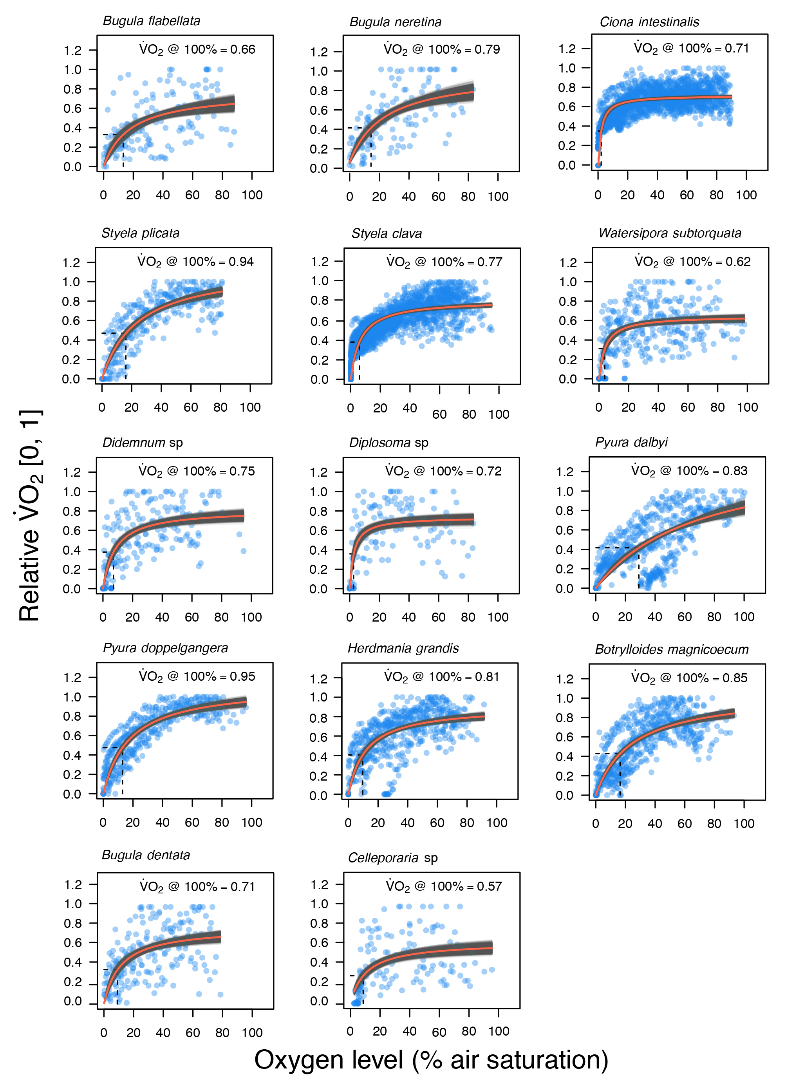

**Fig. 1** Plots of oxygen level (% air saturation) with relative respiration rate of each species measured (, 0-1). The intersection of dashed lines with x-axis shows the average calculated .

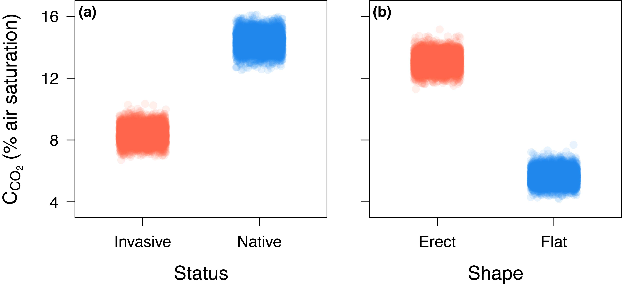

**Fig. 2** Differences in between: (a) species status (native and invasive), and (b) species shape (erect and flat). Each of the 6,000 circles for each category represents an average of estimated by an ANOVA using species-specific values of drawn from MCMC samples from a Michaelis-Menten function fitted in *JAGS*.

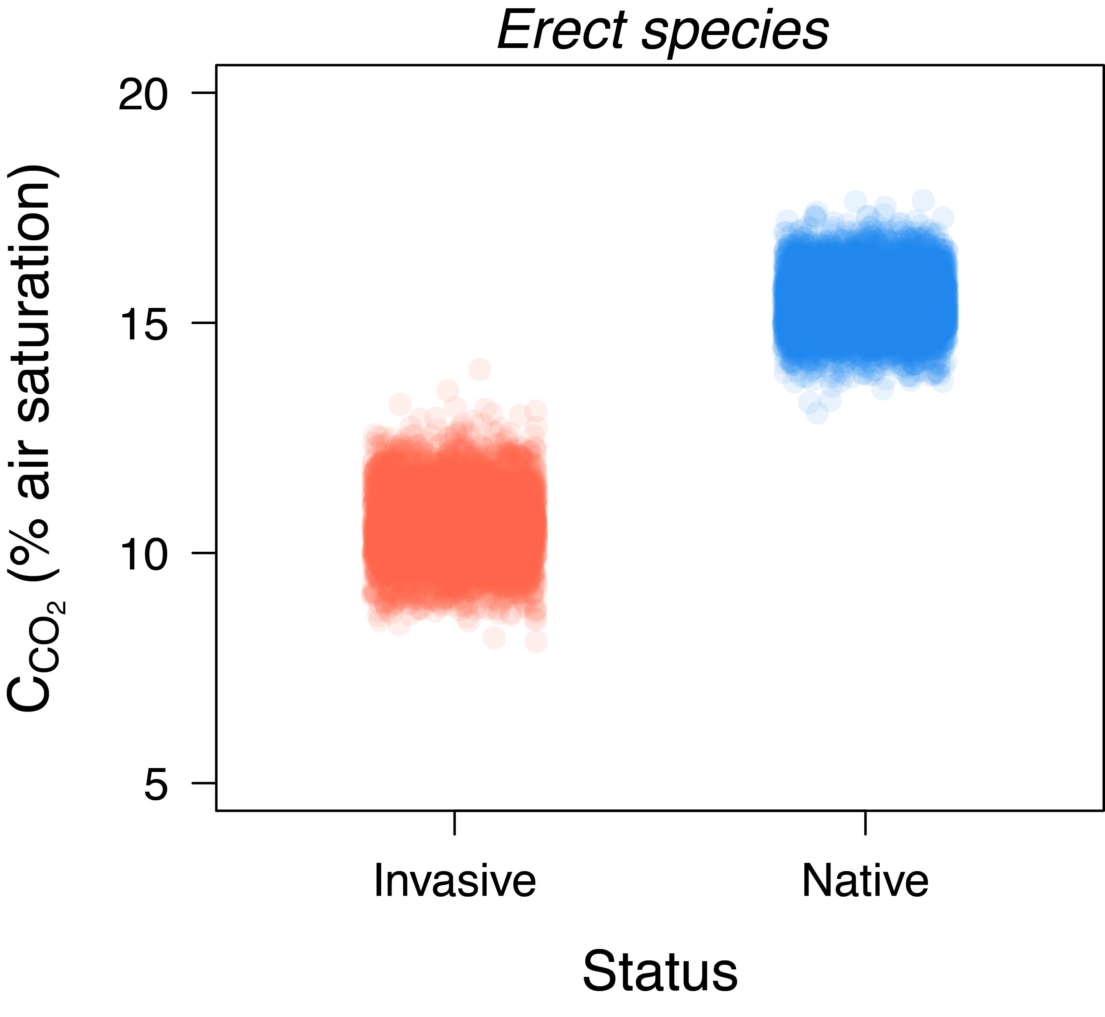

**Fig. 3** Differences in of between status (native and invasive) for “erect shaped species” only. Each of the 6,000 circles for each category represents an average of estimated by an ANOVA using species-specific values of drawn from MCMC samples from a Michaelis-Menten function fitted in *JAGS*.

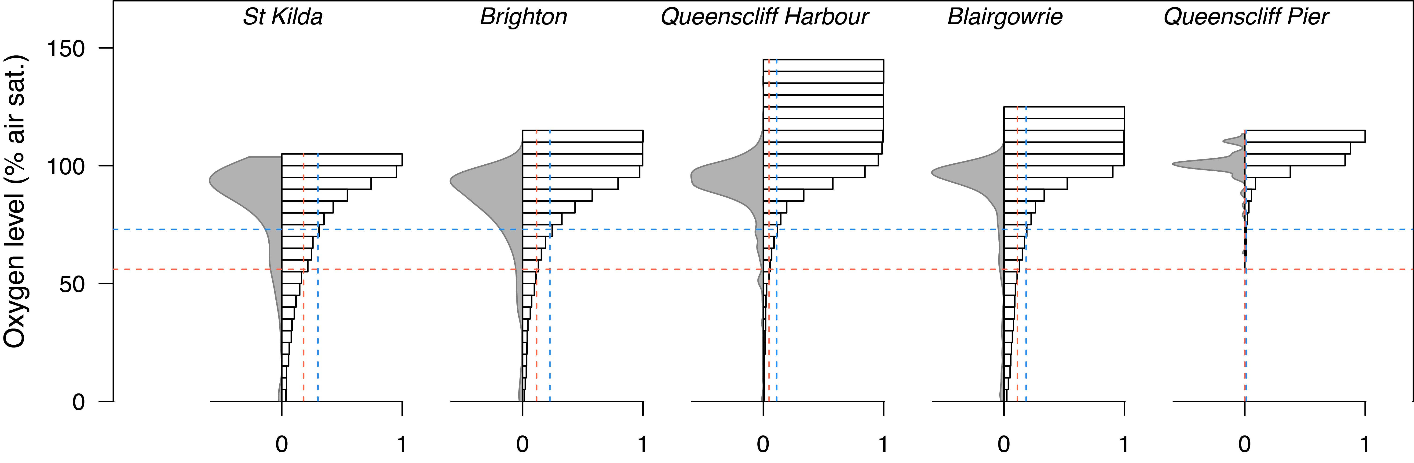

**Fig. 4** Distribution of oxygen level across five different marine sites. Field sites are ordered according to their ranking of their average water speed, from slowest to fastest. Left side of each plot represent frequency distribution of oxygen. Right sides of the plots show cumulative density histograms of oxygen availability for each site. Vertical dashed lines indicate the level where the respiration rate of the animals start to decline (i.e. the value of air saturation in which oxygen consumption is 5% lower than that at 100% air saturation). The horizontal lines correspond to the percentage of microsites that represent physiology stress due to oxygen limitation for native and invasive species form each site. Blue lines are for invasive organisms and red for natives.

**Discussion**

We find that human-made structures, particularly marinas, cause reductions in local availability of oxygen in marine environments, and in some cases, push oxygen levels below the tolerance of the species that could live there, particularly native species. Environments with higher water flow provide almost exclusively normoxic microsites with low spatial and temporal variation in oxygen levels. On the other hand, low flow environments show higher variation in oxygen levels in both space and time. Flat species have greater tolerance to hypoxic conditions than erect species, a result that echoes previous studies in warm water sessile marine invertebrate communities (Ferguson *et al.*, 2013). Most importantly, we found that invasive species can tolerate lower oxygen levels than native species – invasive species could maintain a at oxygen levels that were ~1.7-fold lower than those of native species. Based on the values reported here, we calculated that in some sites, up to 30% of the microsites are physiologically stressful for native species.

Previous studies have recorded broad scale reductions in oxygen levels in low flow marinas ([Stammerjohn](#_ENREF_54" \o "Stammerjohn, 1991 #453) *[et al.](#_ENREF_54" \o "Stammerjohn, 1991 #453)*[, 1991](#_ENREF_54" \o "Stammerjohn, 1991 #453)), but few have explored oxygen levels at the scales that are likely to be relevant to organisms. Our approach is likely to slightly overestimate oxygen availability in the field. We measured oxygen during daylight hours and in regions that were exposed to ambient light. Oxygenation of the boundary layer from photosynthesis by micro-phyto-benthos will therefore increase local oxygen levels during the day relative to those same areas at night (for analogous effects in tide pools, coral reefs and other low flow systems see: ([Dodds](#_ENREF_15" \o "Dodds, 2007 #413) *[et al.](#_ENREF_15" \o "Dodds, 2007 #413)*[, 2007](#_ENREF_15" \o "Dodds, 2007 #413), [Kinsey & Kinsey, 1967](#_ENREF_27" \o "Kinsey, 1967 #418), [Nilsson & Ostlund-Nilsson, 2004](#_ENREF_40" \o "Nilsson, 2004 #414), [Osinga](#_ENREF_42" \o "Osinga, 1999 #412) *[et al.](#_ENREF_42" \o "Osinga, 1999 #412)*[, 1999](#_ENREF_42" \o "Osinga, 1999 #412)). We found generally higher estimates of oxygen availability in Port Phillip Bay relative to a similar study in a marina in subtropical Australia ([Ferguson](#_ENREF_17" \o "Ferguson, 2013 #136) *[et al.](#_ENREF_17" \o "Ferguson, 2013 #136)*[, 2013](#_ENREF_17" \o "Ferguson, 2013 #136)). The subtropical site had similar or higher flow rates than the sites we measured, so differences in flow are unlikely to explain the observed difference in oxygen availability. We suspect that the higher temperature at the subtropical site (25 °C there versus 19 °C during our study) increased the metabolic demands of the local community, leading to lower oxygen levels overall. An important next step would be to determine whether oxygen availability covaries with seasonal changes in temperature at the study sites of the present study. Interestingly, even with differences in mean oxygen availability at the subtropical site and the St Kilda site, we find a similar percentage of habitat is predicted to be physiologically stressful to that found in the previous study ([Ferguson](#_ENREF_17" \o "Ferguson, 2013 #136) *[et al.](#_ENREF_17" \o "Ferguson, 2013 #136)*[, 2013](#_ENREF_17" \o "Ferguson, 2013 #136)).

We aware that our estimates of in which = as our proxy for is an arbitrary point. When cannot be sure that this point represents exactly the moment when the transition from aerobic to anaerobic occurs; finding this point could be future research and needs to be tested. However, as a first approach we can say that at least the values we got represent the point where the metabolic activity is half of the maximum and that are similar to found for other sessile marine organisms and fishes ([Ferguson](#_ENREF_17" \o "Ferguson, 2013 #136) *[et al.](#_ENREF_17" \o "Ferguson, 2013 #136)*[, 2013](#_ENREF_17" \o "Ferguson, 2013 #136), [Nilsson & Ostlund-Nilsson, 2004](#_ENREF_40" \o "Nilsson, 2004 #414)); therefore, we believe the reported values to provide a fairly good indication of hypoxia resistance. In organism as fishes and mammals, which are strong oxyregulators, the can be found in a straightforward way, as they keep their oxygen consumption constant until they are exposed to a critical oxygen level ([Portner & Grieshaber, 1993](#_ENREF_48" \o "Portner, 1993 #446)). However, animals we measured presented responses more associated with a oxyconformeres strategy, as they reduce their oxygen uptake with the reduction of the environmental oxygen. We suggest that for more details about differences between oxyconformity and oxyregulation read Magnums & Vanwinkl (1973) and Portner & Grieshaber (1993). Oxyconformers rely on anaerobiosis at very low oxygen levels ([Portner & Grieshaber, 1993](#_ENREF_48" \o "Portner, 1993 #446)), hence the functional groups measured here may be considered hypoxia tolerant, as they were able to withstand oxygen levels under around 1.8 mg l-1, ~ 25 % air saturation at 19 °C. Flat organisms, however, were able to withstand more extreme hypoxic conditions, and overall had lower values than erect species. Flat species are prone to live in low oxygen environments, as the boundary layers where they live are highly likely to be oxygen depleted ([Ferguson](#_ENREF_17" \o "Ferguson, 2013 #136) *[et al.](#_ENREF_17" \o "Ferguson, 2013 #136)*[, 2013](#_ENREF_17" \o "Ferguson, 2013 #136), [Shashar](#_ENREF_50" \o "Shashar, 1993 #416) *[et al.](#_ENREF_50" \o "Shashar, 1993 #416)*[, 1993](#_ENREF_50" \o "Shashar, 1993 #416)). On the other hand, at least the adult stages of erect species may not need to adapt to extreme hypoxic environments, as they can grow beyond the limits of the boundary layer and access more oxygenated water.

Invasive species presented a lower than natives. Moreover, we also found that erect-invasive organisms had lower values than erect-natives. Because we only had one native-flat species in our data set, we could not formally compare native and invasive flat species. However, we note that the flat-invasive organisms had the lowest across all functional groups, and could withstand extremely hypoxic levels (~ 5 % air saturation). Within the context of R* theory, species with low (or should be better competitors than species with higher because they can maintain aerobic metabolism at relatively higher rates in hypoxic conditions. It has also been demonstrated that species with low can diminish the oxygen in the areas immediately surrounding them, leaving little oxygen available for other species (Ferguson *et al.*, 2013). It therefore seems that exploitative competition for oxygen has the potential to play an important role in marine invasions.

Across a range of taxa and systems, invasive species tend to have characteristics that make them more resistant to stressful conditions than native species (Lejeusne *et al.*, 2014, van Kleunen *et al.*, 2010b, Zerebecki & Sorte, 2011). Some studies suggest that invasive species are evolving to tolerate anthropogenic perturbations. For example, heavy metals, antifouling agents and other pollutants are selective pressures that favor invasive organisms, and studies of invasive species have shown that resistance to pollutants can be heritable (Floerl & Inglis, 2005, Levinton *et al.*, 2003, McKenzie *et al.*, 2011, Piola *et al.*, 2009) . Tolerance to lower oxygen levels has evolved independently many times, as a response to environments where hypoxic conditions or strong fluctuations in oxygen availability dominate (Hochachka & Lutz, 2001, Mandic *et al.*, 2009, Nilsson & Ostlund-Nilsson, 2004). Usually the physiological thresholds of the species matches the minimum oxygen level of the environment, therefore hypoxia tolerance is an important trait that can determine the distribution and abundance of organisms (Lagos *et al.*, 2011, Stillman & Somero, 1996, Verberk *et al.*, 2011). We do not know if resistance to hypoxia in invasive organisms is a heritable trait, or whether this trait is an example of phenotypic plasticity. However, the reduction of oxygen levels associated with artificial structures may be acting as a selection pressure that favors invasive organisms. We would therefore suggest that species that are already tolerant to low oxygen conditions might be more likely to become invasive if translocated by humans.

Our results suggest that artificial structures provide windows for invasion via mediation of water flow. As lowering water flow increases the prevalence of hypoxic and anoxic microsites it is likely that a higher proportion of such habitats are hostile to native species while still allowing invasive species to function normally. From a management perspective, artificial structures that maintain water flow rates that result in the adequate replenishment of oxygen at local scales might be more effective at promoting the proliferation of native species and discouraging invasion.

**Acknowledgements**

The authors thank to Blairgowrie Yacht Squadron, Royal Brighton Yacht Club, Royal Melbourne Yacht Squadron and Queenscliff Harbour for access to the field site. We thank Amanda Pettersen and Hayley Cameron for their help in the elaboration of the draft of this paper, Martino Malerba for statistical advice, Mattia Pierangelini, Camila Arnes and Yussi Palacios for their help in the field. C.R.W. and D.J.M. were supported by grants from the Australian Research Council. M.E.L. is supported by grants from Conicyt Becas-Chile Scholarship. D.R.B. is funded by the Monash University Centre for Geometric Biology.

**Data accessibility**

All data and R code (analyses, figures and tables) can be downloaded from a GitHub repository (<https://github.com/dbarneche/vo2Inverts>), which will be made publicly available upon publication.

**References**

Airoldi L, Turon X, Perkol-Finkel S, Rius M (2015) Corridors for aliens but not for natives: effects of marine urban sprawl at a regional scale. Diversity and Distributions*,* **21**, 755-768.

Andow DA, Kareiva PM, Levin SA, Okubo A (1990) Spread of invading organisms. Landscape Ecology*,* **4**, 177-188.

Arim M, Abades SR, Neill PE, Lima M, Marquet PA (2006) Spread dynamics of invasive species. Proceedings of the National Academy of Sciences of the United States of America*,* **103**, 374-378.

Armstrong W, Webb T, Darwent M, Beckett PM (2009) Measuring and interpreting respiratory critical oxygen pressures in roots. Annals of Botany*,* **103**, 281-293.

Bulleri F, Airoldi L (2005) Artificial marine structures facilitate the spread of a non-indigenous green alga, *Codium fragile* ssp. tomentosoides, in the north Adriatic Sea. Journal of Applied Ecology*,* **42**, 1063-1072.

Chesson P (2000) General theory of competitive coexistence in spatially-varying environments. Theoretical Population Biology*,* **58**, 211-237.

Clark GF, Johnston EL (2005) Manipulating larval supply in the field: a controlled study of marine invasibility. Marine Ecology-Progress Series*,* **298**, 9-19.

Colautti RI, Macisaac HJ (2004) A neutral terminology to define 'invasive' species. Diversity and Distributions*,* **10**, 135-141.

Crawley MJ, Kornberg H, Lawton JH, Usher MB, Southwood R, O'connor RJ, Gibbs A (1986) The Population Biology of Invaders [and Discussion]. Philosophical Transactions of the Royal Society of London. B, Biological Sciences*,* **314**, 711-731.

Cullis JDS, Gillis CA, Bothwell ML, Kilroy C, Packman A, Hassan M (2012) A conceptual model for the blooming behavior and persistence of the benthic mat-forming diatom *Didymosphenia geminata* in oligotrophic streams. Journal of Geophysical Research-Biogeosciences*,* **117**.

Dafforn KA, Glasby TM, Johnston EL (2009a) Links between estuarine condition and spatial distributions of marine invaders. Diversity and Distributions*,* **15**, 807-821.

Dafforn KA, Johnston EL, Glasby TM (2009b) Shallow moving structures promote marine invader dominance. Biofouling*,* **25**, 277-287.

Davies KF, Chesson P, Harrison S, Inouye BD, Melbourne BA, Rice KJ (2005) Spatial heterogeneity explains the scale dependence of the native-exotic diversity relationship. Ecology*,* **86**, 1602-1610.

Davis MA (2003) Biotic globalization: Does competition from introduced species threaten biodiversity? Bioscience*,* **53**, 481-489.

Dodds LA, Roberts JM, Taylor AC, Marubini F (2007) Metabolic tolerance of the cold-water coral *Lophelia pertusa* (Scleractinia) to temperature and dissolved oxygen change. Journal of Experimental Marine Biology and Ecology*,* **349**, 205-214.

Erfmeier A, Hantsch L, Bruelheide H (2013) The Role of Propagule Pressure, Genetic Diversity and Microsite Availability for Senecio vernalis Invasion. Plos One*,* **8**.

Ferguson N, White CR, Marshall DJ (2013) Competition in benthic marine invertebrates: the unrecognized role of exploitative competition for oxygen. Ecology*,* **94**, 126-135.

Floerl O, Inglis GJ (2005) Starting the invasion pathway: the interaction between source populations and human transport vectors. Biological Invasions*,* **7**, 589-606.

Gardella DJ, Edmunds PJ (1999) The oxygen microenvironment adjacent to the tissue of the scleractinian *Dichocoenia stokesii* and its effects on symbiont metabolism. Marine Biology*,* **135**, 289-295.

Glasby TM, Connell SD, Holloway MG, Hewitt CL (2007) Nonindigenous biota on artificial structures: could habitat creation facilitate biological invasions? Marine Biology*,* **151**, 887-895.

Hart SP, Marshall DJ (2009) Spatial arrangement affects population dynamics and competition independent of community composition. Ecology*,* **90**, 1485-1491.

Hart SP, Marshall DJ (2012) Advantages and disadvantages of interference-competitive ability and resource-use efficiency when invading established communities. Oikos*,* **121**, 396-402.

Hochachka PW, Lutz PL (2001) Mechanism, origin, and evolution of anoxia tolerance in animals. Comparative Biochemistry and Physiology B-Biochemistry & Molecular Biology*,* **130**, 435-459.

Hochachka PW, Somero GN (2002) Biochemical Adaptation : Mechanism and Process in Physiological Evolution. pp Page, New York, Oxford University Press.

Keane RM, Crawley MJ (2002) Exotic plant invasions and the enemy release hypothesis. Trends in Ecology & Evolution*,* **17**, 164-170.

Kinlan BP, Gaines SD (2003) Propagule dispersal in marine and terrestrial environments: A community perspective. Ecology*,* **84**, 2007-2020.

Kinsey D, Kinsey E (1967) Diurnal changes in oxygen content of the water over the coral reef platform at Heron I. Marine and Freshwater Research*,* **18**, 23-34.

Koch EW, Gust G (1999) Water flow in tide- and wave-dominated beds of the seagrass *Thalassia testudinum*. Marine Ecology Progress Series*,* **184**, 63-72.

Lagos ME, Munoz JL, Contreras DA, Caceres CW (2011) Microhabitat segregation and physiological differences in two species of intertidal porcellanid crabs (Genus *Petrolisthes*) on the southern coast of Chile. Scientia Marina*,* **75**, 273-278.

Lastra M, Jaramillo E, Lopez J, Contreras H, Duarte C, Rodriguez JG (2004) Population abundances, tidal movement, burrowing ability and oxygen uptake of *Emerita analoga* (Stimpson) (Crustacea, Anomura) on a sandy beach of south-central Chile. Marine Ecology-Pubblicazioni Della Stazione Zoologica Di Napoli I*,* **25**, 71-89.

Lejeusne C, Latchere O, Petit N, Rico C, Green AJ (2014) Do invaders always perform better? Comparing the response of native and invasive shrimps to temperature and salinity gradients in southwest Spain. Estuarine Coastal and Shelf Science*,* **136**, 102-111.

Levinton JS, Suatoni E, Wallace W, Junkins R, Kelaher B, Allen BJ (2003) Rapid loss of genetically based resistance to metals after the cleanup of a Superfund site. Proceedings of the National Academy of Sciences of the United States of America*,* **100**, 9889-9891.

Mack RN, Simberloff D, Lonsdale WM, Evans H, Clout M, Bazzaz FA (2000) Biotic Invasions: Causes, Epidemiology, Global Consequences, and Control. Ecological Applications*,* **10**, 689-710.

Mandic M, Todgham AE, Richards JG (2009) Mechanisms and evolution of hypoxia tolerance in fish. Proceedings of the Royal Society B-Biological Sciences*,* **276**, 735-744.

Marshall DJ, Bode M, White CR (2013) Estimating physiological tolerances - a comparison of traditional approaches to nonlinear regression techniques. Journal of Experimental Biology*,* **216**, 2176.

Mckenzie LA, Brooks R, Johnston EL (2011) Heritable pollution tolerance in a marine invader. Environmental Research*,* **111**, 926-932.

Mckenzie LA, Brooks RC, Johnston EL (2012) A widespread contaminant enhances invasion success of a marine invader. Journal of Applied Ecology*,* **49**, 767-773.

Moore KA, Neckles HA, Orth RJ (1996) *Zostera marina* (eelgrass) growth and survival along a gradient of nutrients and turbidity in the lower Chesapeake Bay. Marine Ecology Progress Series*,* **142**, 247-259.

Neill PE, Arim M (2011) Human heatlh link to invasive species In: *Encyclopedia of environmental health* (ed Nriagu JO) pp Page. Burlington, Elsevier.

Nilsson GE, Ostlund-Nilsson S (2004) Hypoxia in paradise: widespread hypoxia tolerance in coral reef fishes. Proceedings of the Royal Society B-Biological Sciences*,* **271**, S30-S33.

Okamura B (1985) The effects of ambient flow velocity, colony size, and upstream colonies on the feeding success of bryozoa .2. *Conopeum-reticulum* (linnaeus), an encrusting species. Journal of Experimental Marine Biology and Ecology*,* **89**, 69-80.

Osinga R, Tramper J, Wijffels RH (1999) Cultivation of marine sponges. Marine Biotechnology*,* **1**, 509-532.

Palardy JE, Witman JD (2011) Water flow drives biodiversity by mediating rarity in marine benthic communities. Ecology Letters*,* **14**, 63-68.

Persson L (1985) Asymmetrical competition - are larger animals competitively superior. American Naturalist*,* **126**, 261-266.

Pettersen AK, White CR, Marshall DJ (2015) Why does offspring size affect performance? Integrating metabolic scaling with life-history theory. Proceedings. Biological sciences / The Royal Society*,* **282**.

Pimentel D, Mcnair S, Janecka J *et al.* (2001) Economic and environmental threats of alien plant, animal, and microbe invasions. Agriculture Ecosystems & Environment*,* **84**, 1-20.

Piola RF, Dafforn KA, Johnston EL (2009) The influence of antifouling practices on marine invasions. Biofouling*,* **25**, 633-644.

Portner HO, Grieshaber MK (1993) Critical p(o)(2)(s) in oxyconforming and oxyregulating animals - gas-exchange, metabolic-rate and the mode of energy-production*,* Boca Raton, Crc Press Inc.

Ruiz G, Freestone A, Fofonoff P, Simkanin C (2009) Habitat Distribution and Heterogeneity in Marine Invasion Dynamics: the Importance of Hard Substrate and Artificial Structure. In: *Marine Hard Bottom Communities.* (ed Wahl M) pp Page., Springer Berlin Heidelberg.

Shashar N, Cohen Y, Loya Y (1993) Extreme diel fluctuations of oxygen in diffusive boundary-layers surrounding stony corals. Biological bulletin*,* **185**, 455-461.

Shea K, Chesson P (2002) Community ecology theory as a framework for biological invasions. Trends in Ecology &amp; Evolution*,* **17**, 170-176.

Shimeta J, Jumars PA (1991) Physical-mechanisms and rates of particle capture by suspension-feeders. Oceanography and Marine Biology*,* **29**, 191-257.

Simberloff D, Von Holle B (1999) Positive Interactions of Nonindigenous Species: Invasional Meltdown? Biological Invasions*,* **1**, 21-32.

Stammerjohn S, Smith E, Boynton WR, Kemp WM (1991) *Potential impacts from marinas and boats in Baltimore Harbor,* Solomons, MD, Chesapeake Research Consortium.

Stillman J, Somero GN (1996) Adaptation to temperature stress and aerial exposure in congeneric species of intertidal porcelain crabs (genus *Petrolisthes*): Correlation of physiology, biochemistry and morphology with vertical distribution. Journal of Experimental Biology*,* **199**, 1845-1855.

Sundareshwar PV, Upadhayay S, Abessa M *et al.* (2011) *Didymosphenia geminata*: Algal blooms in oligotrophic streams and rivers. Geophysical Research Letters*,* **38**.

Svensson JR, Marshall DJ (2015) Limiting resources in sessile systems: food enhances diversity and growth of suspension feeders despite available space. Ecology*,* **96**, 819-827.

Tilman D (2004) Niche tradeoffs, neutrality, and community structure: A stochastic theory of resource competition, invasion, and community assembly. Proceedings of the National Academy of Sciences of the United States of America*,* **101**, 10854-10861.

Van Kleunen M, Dawson W, Schlaepfer D, Jeschke JM, Fischer M (2010a) Are invaders different? A conceptual framework of comparative approaches for assessing determinants of invasiveness. Ecology Letters*,* **13**, 947-958.

Van Kleunen M, Weber E, Fischer M (2010b) A meta-analysis of trait differences between invasive and non-invasive plant species. Ecology Letters*,* **13**, 235-245.

Verberk WCEP, Bilton DT, Calosi P, Spicer JI (2011) Oxygen supply in aquatic ectotherms: Partial pressure and solubility together explain biodiversity and size patterns. Ecology*,* **92**, 1565-1572.

Vitousek PM, Dantonio CM, Loope LL, Westbrooks R (1996) Biological invasions as global environmental change. American Scientist*,* **84**, 468-478.

Vogel S (1994) *Life in Moving Fluids: The Physical Biology of Flow*, Princeton University Press.

White CR, Kearney MR, Matthews PGD, Kooijman S, Marshall DJ (2011) A Manipulative Test of Competing Theories for Metabolic Scaling. American Naturalist*,* **178**, 746-754.

Wilding TA (2014) Effects of man-made structures on sedimentary oxygenation: Extent, seasonality and implications for offshore renewables. Marine Environmental Research*,* **97**, 39-47.

Zerebecki RA, Sorte CJB (2011) Temperature Tolerance and Stress Proteins as Mechanisms of Invasive Species Success. Plos One*,* **6**.

Zhao DP, Feng PS (2015) Temperature increase impacts personality traits in aquatic non-native species: Implications for biological invasion under climate change. Current Zoology*,* **61**, 966-971.